Hibernate One to One Mapping Example Annotation
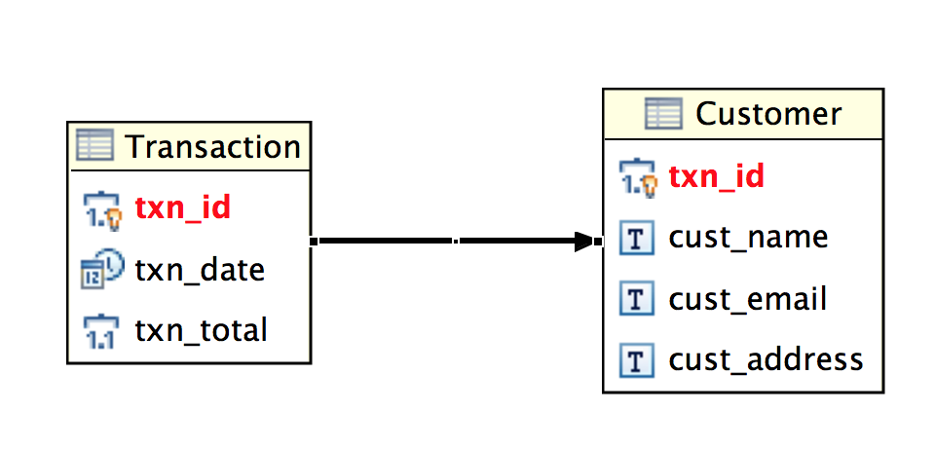

@Entity
@Table(name="TRANSACTION")
public class Txn {

@OneToOne(mappedBy="txn") @Cascade(value=org.hibernate.annotations.CascadeType.SAVE_UPDATE)
private Customer customer;
}

@Entity
@Table(name="CUSTOMER")
public class Customer {
@OneToOne
@PrimaryKeyJoinColumn
private Txn txn;

}

Hibernate One To Many Mapping Example Annotation
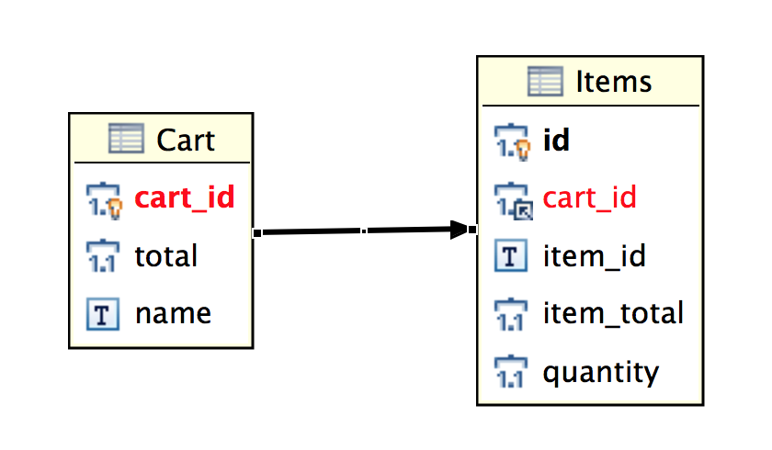
@Entity
@Table(name="CART")
public class Cart {
@OneToMany(mappedBy="cart")
private Set<Items> items;

}

@Entity
@Table(name="ITEMS")
public class Items {
@ManyToOne
@JoinColumn(name="cart_id", nullable=false)
private Cart cart;
}

Hibernate – Many-to-Many example
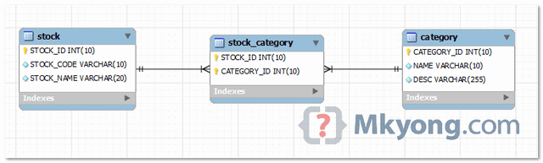
@Entity
@Table(name = "stock", catalog = "mkyongdb", uniqueConstraints = {
@UniqueConstraint(columnNames = "STOCK_NAME"),
@UniqueConstraint(columnNames = "STOCK_CODE") })
public class Stock implements java.io.Serializable {
private Integer stockId;
private String stockCode;
private String stockName;
private Set<Category> categories = new HashSet<Category>(0);
@ManyToMany(fetch = FetchType.LAZY, cascade = CascadeType.ALL)
@JoinTable(name = "stock_category", catalog = "mkyongdb", joinColumns = {
@JoinColumn(name = "STOCK_ID", nullable = false, updatable = false) },
inverseJoinColumns = { @JoinColumn(name = "CATEGORY_ID",
nullable = false, updatable = false) })
public Set<Category> getCategories() {
return this.categories;
}
}

@Entity
@Table(name = "category", catalog = "mkyongdb")
public class Category implements java.io.Serializable {
private Integer categoryId;
private String name;
private String desc;
private Set<Stock> stocks = new HashSet<Stock>(0);
@ManyToMany(fetch = FetchType.LAZY, mappedBy = "categories")
public Set<Stock> getStocks() {
return this.stocks;
}
}

